CONFIDENTIAL INFORMATION MEMORANDUM

Table of Contents:

1)Executive summary

2)Key Investment Highlights

3)Company Overview

4)Market Overview

5)Financial Projections

Executive summary:

Ola electric , the market leading Indian electric 2-wheeler manufacturer is exploring a 100% stake sale to investors , with increasing revenue and dominant lead in the market they would like to expand their innovation and infrastructure . Ola electric seeks long term-capital support. With over 4000 strategically placed stores and fast increasing hypercharger network across Indian metros, Ola electric sits in the center of Electric 2wheelers in India
This CIM showcases the detailed insights into the Business , market and financials for evaluation by investors (post NDA confirmation)

1.1)Products and services offered :

Ola electric offers a variety of 2wheelers starting from scooters to bikes,
With new variants in the pipeline and expected to be delivered by july’25 , this marks their entry into the segment in the industry focusing on bike-sharing / motorbike riding.

The company offers charging services at all its store locations as well as many other outlets , all together they have 978 charging points with 288 hypercharging points in over 60 cities , they also operate a multitude of stores closing 4000 in number.

1.2) Market opportunity :

India is one of the world’s fastest-growing markets for Electric Two-Wheelers (E2Ws). The two-wheeler segment dominates the Indian automobile market, accounting for more than 70% of all registered vehicles. With a per-capita income of $2,880, the majority of Indian families can afford a two-wheeler — a trend confirmed by the historically strong popularity of 2Ws, making India the second-largest two-wheeler market globally, currently valued at $18 billion.

Sales in EV Indian 2-wheeler market have increased exponentially over the last decade. The total sales have increased to 1.95 million units in CY2024 a 33% increase from 1.53millio units in 2023 . This indicates a rising demand in electric 2 wheelers which currently occupy an dominant 60% market share of the total Indian EV landscape. India’s electric mobility sector is undergoing rapid acceleration, driven by favorable government policies (FAME-II subsidies, PLI schemes), rising petrol costs, and growing ESG-conscious consumer preferences.

1.3) Company’s Mission and Exit Strategy:
The company was founded on the goal to decarbonize urban mobility and provide clean and affordable transport solutions , Ola electric believes in strengthening Indigenous production and taking the company into international markets with a consumer first approach.

Ola electric seeks a full stake sale to facilitate capital infusion for upcoming giga factories and explore global outlook. The CEO and majority share holder Bhavesh Agarwal wants to allow his creation to achieve higher heights under competent management with international outlook.

1.4) Management Team:

Ola Electric is led by Bhavish Aggarwal, a serial entrepreneur and visionary in the Indian mobility space. With over 15 years of leadership experience at Ola, Bhavish has cemented his legacy as a transformative force in the industry. Backed by strategic investors, he is committed to propelling the company into its next phase.

The leadership team comprises seasoned professionals with deep expertise across automotive engineering, EV battery systems, and large-scale manufacturing. Together, they bring a proven track record of scaling high-growth businesses and executing on complex operational strategies. The core leadership team is expected to remain in place post-transaction, ensuring continuity, while the board structure remains flexible as earlier investors look to exit.

KEY INVESTMENT HIGHLIGHTS

- Market Leadership in India’s Electric Two-Wheeler Segment
Ola Electric commands an estimated 30–35% market share. The company’s share has seen steady growth, supported by a growing product lineup, brand recognition, and first-mover advantage in the Indian EV 2W market.

- End-to-End Integration Across the EV Value Chain
The company is on its course to attain complete vertical integration. Currently, both the Gigafactory and FutureFactory are in full swing, manufacturing cutting-edge 4680 battery cells as well as the entire scooter/bike lineup.

- Ola FutureFactory: World’s Largest Two-Wheeler EV Facility
The plant based in Tamil Nadu has a designed capacity of 10 million units per year, offering significant operating leverage and flexibility for domestic and global demand. Combined with the Ola Gigafactory’s 20 GWh capacity, this makes ola the most technologically advanced company in the EV space.

Ola electrics Production capacity and Utilization is twice that of its nearest competitor as show:

TVS electric
Production capacity:
600,000
Utilization: 32%
Ather
production capacity: 420,000
Utilization : 29%

OLA ELECTRIC:
Production capcity: 1,000,000 vehicles
Utilization : 49%

- Visionary Leadership & Strong Investor Backing:
Founder Bhavish Aggarwal brings 15+ years of entrepreneurial leadership, under him the company has raised over $800M from global investors like SoftBank, Temasek, and Tiger Global.It has also received investments from Korean giants KIA and HYUNDAI.

5.Favorable Government Support Driving Adoption
Schemes such as FAME-II (Faster Adoption and Manufacturing of Hybrid and Electric Vehicles) and the PLI (Production Linked Incentive) program are going to help Ola expand its network and increase EV adoption at a faster rate.

The major contributors along the years have been :
FAME1: 895Cr
FAME2 : 11,500Cr

PLI (the latest initiative to support indigenous EV and battery manufacturing) : 18,100Cr

This cooperative support from the Indian government will help to further decrease the cost of products and increase profit margins

6.Surging EV Two-Wheeler Sales Across Asia & India

India saw EV 2W sales surpass 1.4 million units in FY24, up over 35% YoY, with Southeast Asia showing similar growth. Ola is ideally positioned to benefit from this regional momentum, and combined with its competitive pricing — courtesy of in-house manufacturing — Ola Electric is destined to go international.

Other sectors helped by this demand include ELECTRIC 3W’s which have a shown remarkable growth , with india being the largest market in the world with steady growth till the year 2030.
The graph given below shows the importance of ola electric investments into 3Wheeler technology which will debut in the upcoming years:
18% increase

- Advantages of EV over ICE vehicles :

The cost of operating a EV is negligible compared to that of a ICE vehicle , the use of advanced battery technology reduces service and maintenance cost ,These advantages have enticed consumers and the automobile sector is moving towards a electric future.

The fuel cost comparison between EV and ICE re-enforces this point

Per-day running cost comparison:
- Ola S1 = ₹5
- Petrol scooter = ₹76.5

Per-km running cost:
- Ola S1 = ₹0.17
- Petrol scooter = ₹2.5

This provides convenience & affordability for current customers and is a strong incentive for new customer acquisition.

EV companies as a whole have a advantage over traditional ICE manufacturers in terms of Management structure and vertical integration of EV companies allowing rapid expansion and fast moving ability into new technologies and innovation

COMPANY OVERVIEW

History and Formation

Established in 2017 as a subsidiary of ANI Technologies, Ola Electric is headquartered in Bengaluru. Led by Bhavish Aggarwal, the team quickly entered the E2W market, launching its first EV scooters in late 2021 after making significant investments in key assets.

Manufacturing & Vertical Integration

Ola Electric's strength is in its deep vertical integration. Unlike traditional OEMs that rely on third parties, Ola develops and manufactures all components in-house, from battery packs and drivetrains to vehicular software. This model enables lower costs, direct customer feedback, and tight brand control.

This strategy has led to the creation of:

- The FutureFactory: Located in Tamil Nadu, this is the world's largest two-wheeler factory, built at a cost of $323.89 million on 500 acres of land. It has a current production capacity of 1,000,000 vehicles annually (with a 49% utilization rate) and a potential future capacity of 10 million vehicles. Built to be carbon-neutral with zero landfill usage, it houses the entire assembly line, including an in-house motor and drivetrain line.

- The Gigafactory: Central to Ola’s self-reliant mission, the Gigafactory is the hub of its battery manufacturing. The company has successfully developed its first indigenous 4680 battery cell, featuring high nickel density and designed entirely in-house. The Gigafactory is on track to operate at a full capacity of 20 GWh soon.

- Proprietary software & Digital services:

The company also runs a complete online store where users can buy Ola vehicles fully digitally — without visiting a retail store. This approach, pioneered by Ola in India, has been highly successful. The company has a in-store Prescence as well with over 4000 stores throught Tier1 and Tier2 cities with continuous expansion into smaller towns, the company is now looking to enable non-company-operated stores to further increase reach.

MoveOS is Ola’s proprietary software running on all its vehicles. It offers features such as:
- Over-the-air (OTA) updates
- Real-time diagnostics and predictive maintenance
- Navigation, voice commands, proximity unlock, and ride analytics

- Service infrastructure:
Ola has installed 1,000 charging stations as of 2025, including around 300 hypercharging points. These allow fast charging — offering 50 km of range in just 15 minutes at affordable rates. Ola electric is committed to increase this number to 10,000+ by FY2026

This positions Ola not just as an automotive player but also as a tech-first company. With a massive data stockpile from every vehicle sold, the company gains greater control over its ecosystem, giving it an edge over traditional manufacturers.
This provides a distinct advantage to the company over its competitors.

Other advantages include:
- Lower distribution costs
- Direct customer feedback via the app, which helps tailor offerings and unlock upsell opportunities
- Shared parts across scooter models — nearly 68.5% of components are common among the top 3 models, simplifying sourcing and manufacturing
Vehicles Registered in the year 2024(given below) shows the advantage of this model when compared with a similarly funded company which started in 2021(simultaneously with ola).
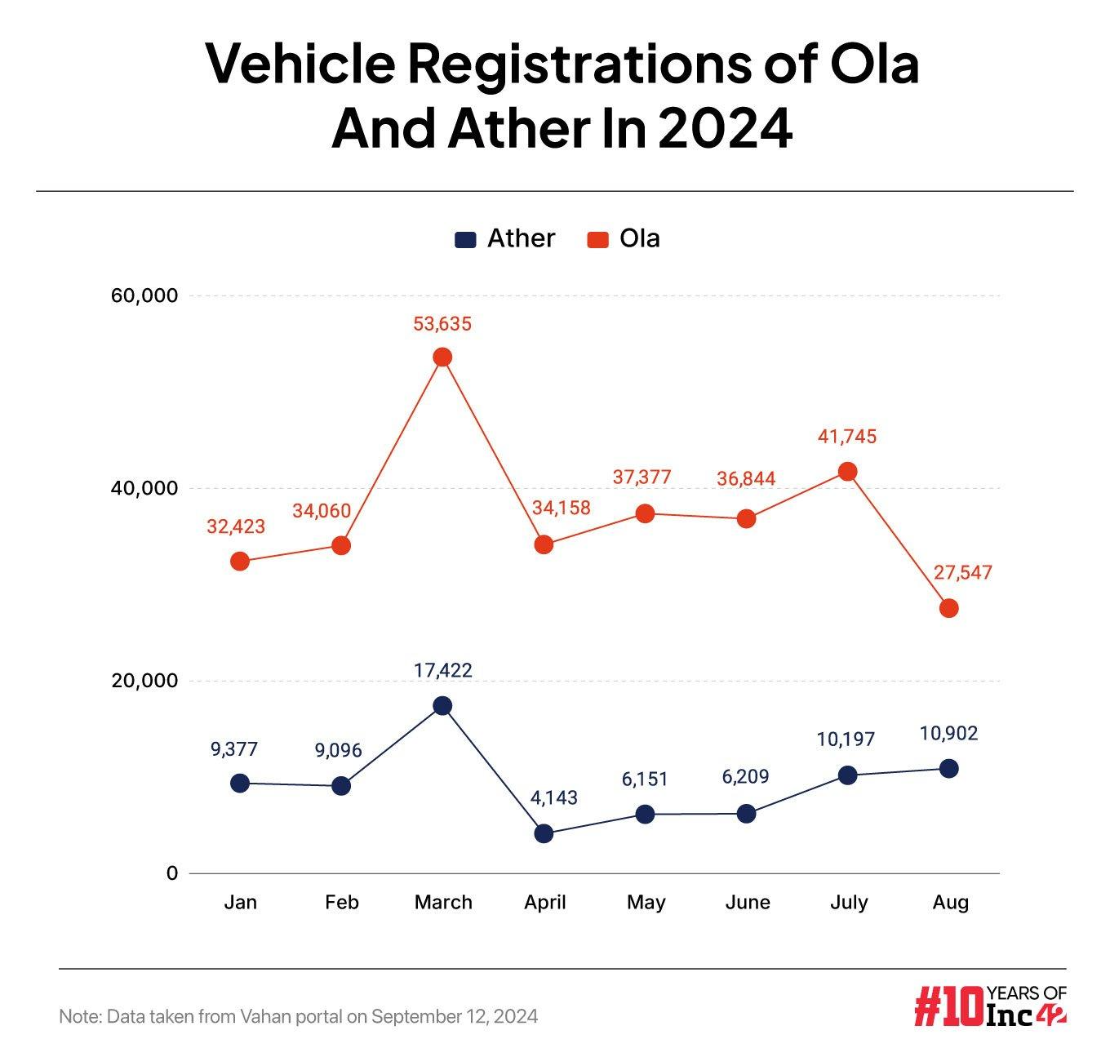

Market dominance of OLA :

Ola electric has been the no.1 selling brand and has held 30%+ market share from the day it had launched , it has reported the highest no of sales in 2024 in history with the launch of their new generation of scooters.Ola Electric has the highest spending in R&D compared to its rivals which gives it an edge in software and hardware alike.

1.1)MARKET SHARE OF OLA ELECTRIC:

Ola electric has been a market leader in the segment and has maintained its position despite competition
(graph indicates % of market)
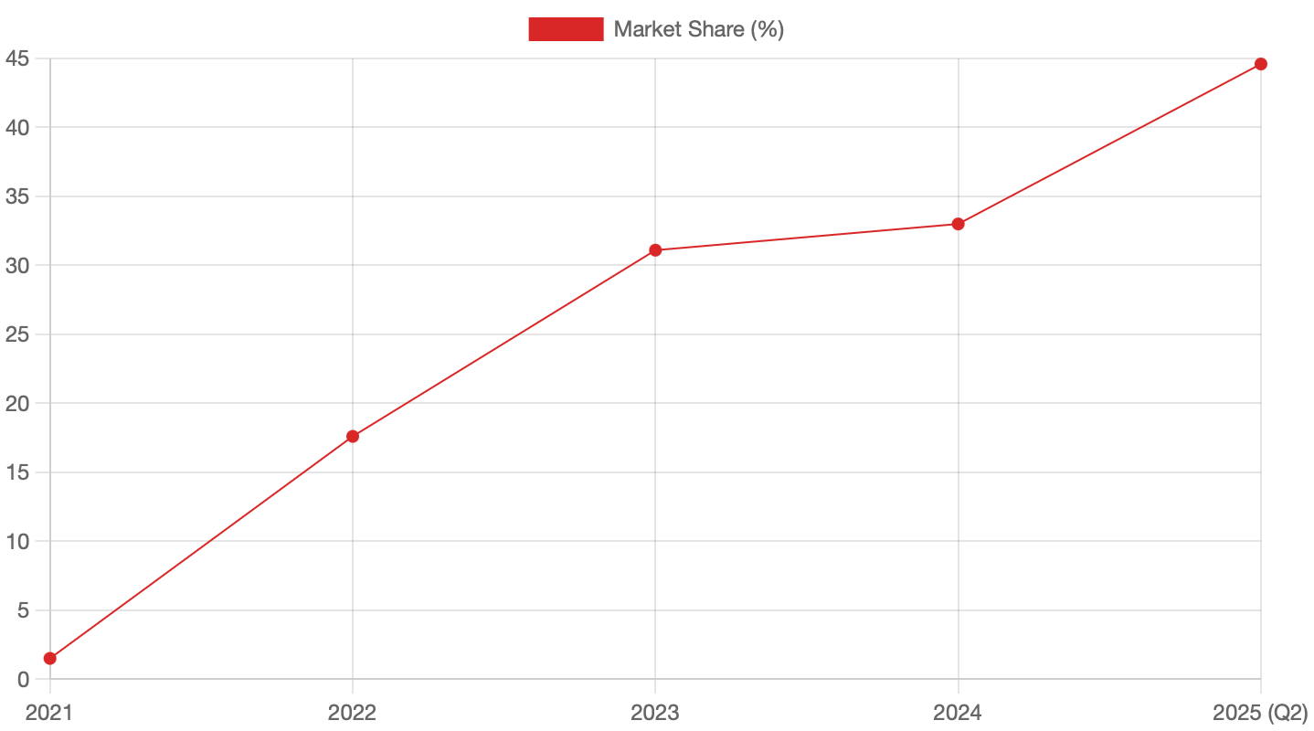

The graph below shows a comparision between no.of.units sold per company(based on top 3 sellers) in India. The adoption of ola electrics new gen fleet has led to increased sales in recent times
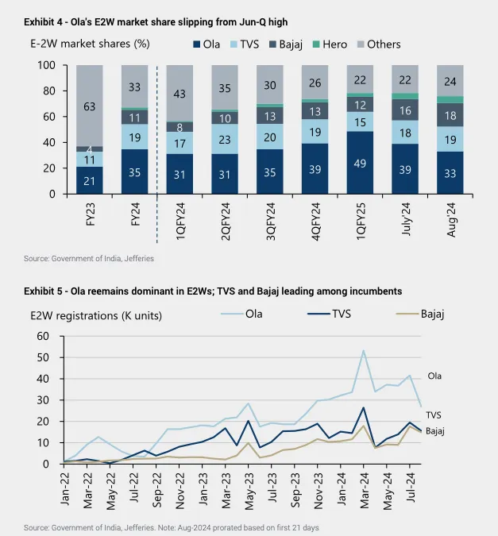

NOTE : The share has undergone a downward trend in 2024 due to increasing competition from legacy automakers yet Ola electric holds a sizeable advantage over the competition.

Revenue model:

The major contributor to revenue is electric scooter sales via its direct-to-consumer model, powered by its mobile app and experience centers.

Complementary income streams include after-sales services (424 service stations), accessories, and emerging software-based monetization through MoveOS.

The company is also building long-term growth levers through its charging infrastructure, fleet/B2B partnerships, and international expansion. It’s also positioned to benefit from carbon credits and ESG incentives — alongside India’s FAME-II and PLI subsidies.

PRODUCTS UNDER OFFER:

Scooters:
- Ola S1PRO+
- Ola S1 Pro
- Ola S1 X+
- Ola S1 x
Motorcycles:
- Roadster X+
- Roadster X
- Roadster
- Roadster Pro

Ola is committed to launching updates of vehicles , a new booking system introduced allows customers to pre order their vehicles allowing Ola to get a cash-influx before the sale of the Vehicle itself.

MODEL WISE SALES IN FY2024:
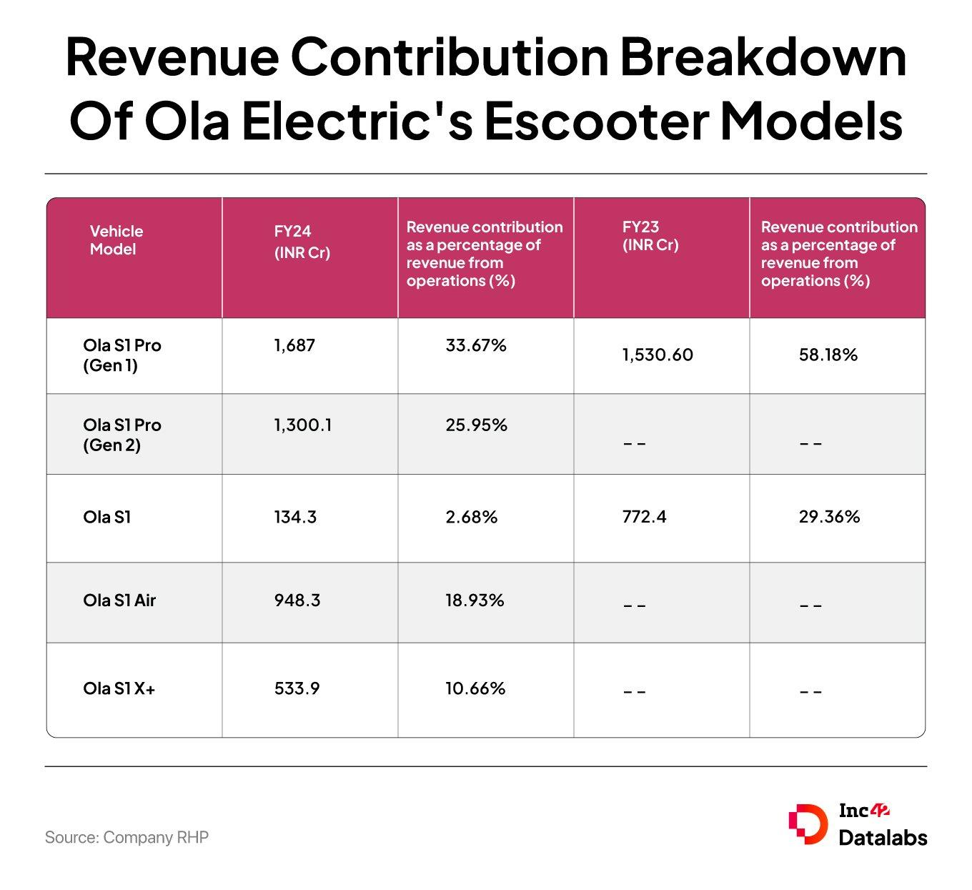
The demand of Ola S1Pro and Ola S1Pro(gen 2) has constantly been more than the more affordable OLA S1Air and OLA S1

Acquisitions:
- Acquired Etergo (Netherlands) in 2020 for £3.75 million to absorb valuable IP and EV expertise.
- In March 2022, Ola made a strategic investment in Israel-based StoreDot to co-develop and manufacture extreme fast-charging (XFC) batteries in India.

Staff and Workforce Structure:

As of October 31, 2023, Ola had a total of 3,733 on-roll employees and 2,844 off-roll employees across India, the UK, and the US.
Function | Number of Employees | Percentage
Research and product development | 889 | 23.81%
Manufacturing operations and supply chain | 1,463 | 39.19%
Support functions | 241 | 6.46%
Sales, service, and fulfillment | 1,140 | 30.54%
Total | 3,733 | 100.00%
Ola maintains a highly inclusive workforce. As of October 31, 2023, the Future Factory’s manufacturing shop floor had 944 female employees, making up 100% of the factory’s on-roll workforce.

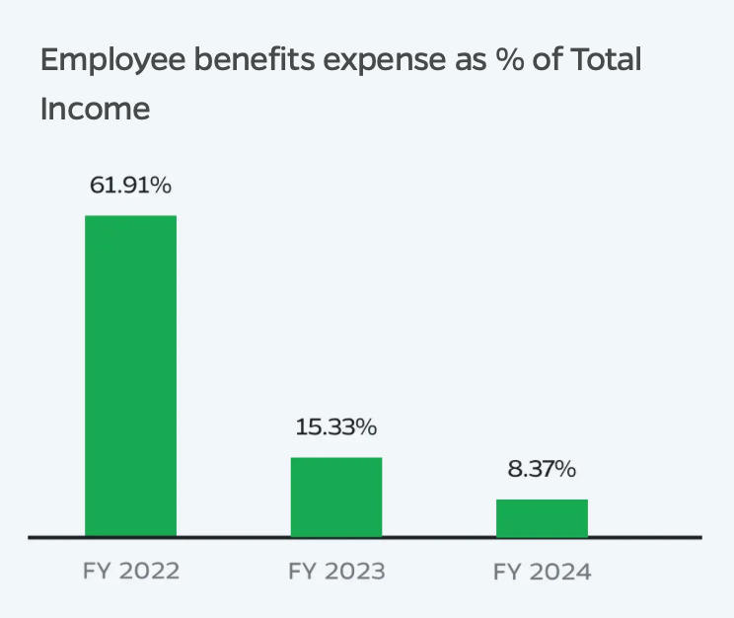

Ola Electric has significantly optimized its employee cost base over the past three years — from 61.91% in FY22 to just 8.37% in FY24 — reflecting increased operating leverage and improved revenue growth.
Source: Company filings

MARKET
OVERVIEW

Development of the industry:

Despite the large volumes, there is significant headroom for further growth. In CY2022, India had only 160 2Ws per 1,000 people, which is still far lower than many Southeast Asian countries, showing untapped potential. The graph below shows the large void to be filled in the Indian market.

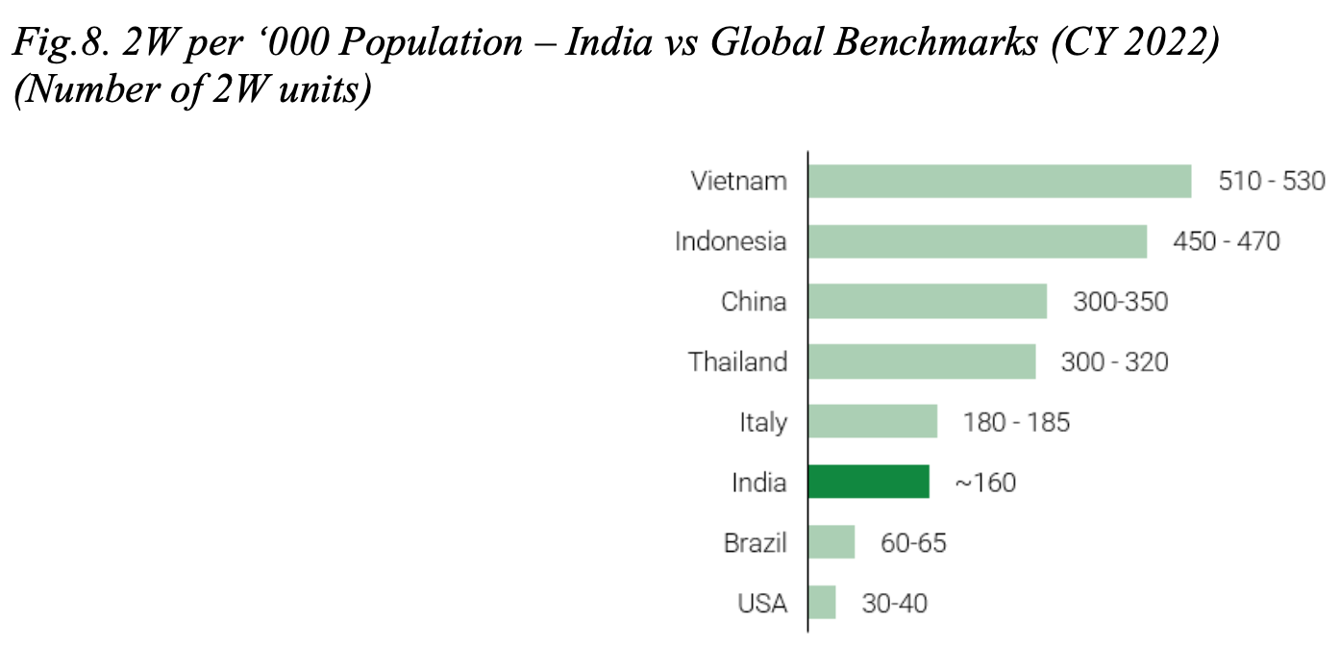

Electrification of Indian 2W market:
The current share of EV’s( 2 wheelers)is at 5% of the total market and is projected to grow to 13% by 2026(Jefferies report) and close to half of the domestic 2W sales volume by FY2028, this increase in demand is not only confined to India but also the emerging markets in Africa and eastern Europe.
The graph below shows EV 2W’S penetration since Ola electric’s debut:

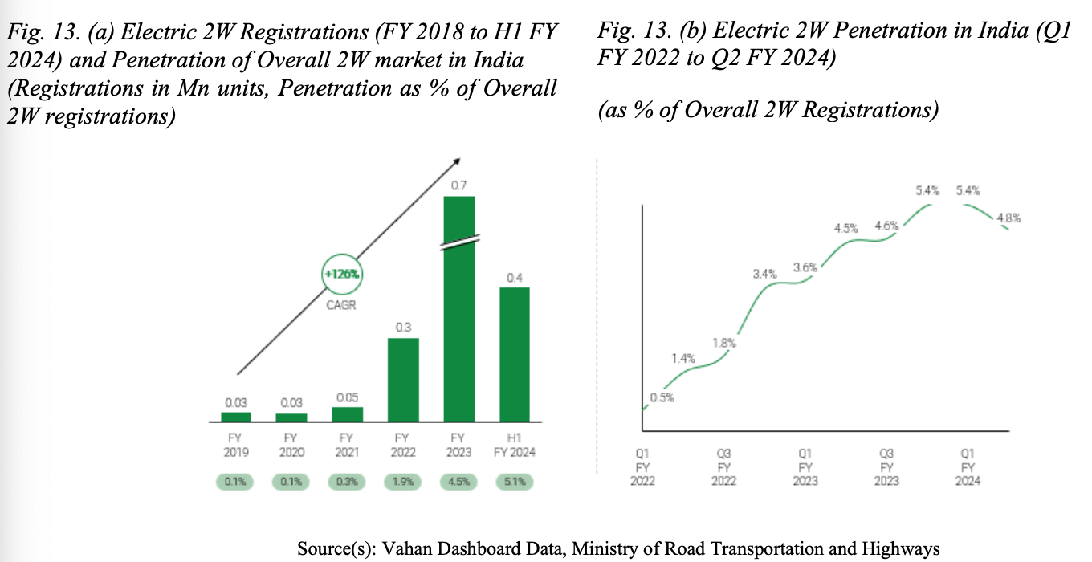

The sales of Electric 2Wheelers has reaches 1.14M units a 21% increase over FY2024
Scooters are leading this E2W penetration:

With the ease of driving and the rise in city commuters , the demands of Scooters have skyrocketed in the Indian 2W market , the versatility of scooters is being able to be used for work as well as household purposes by both the genders , unlike motorbikes.

The segment wise 2Wheeler graph(given below) supports the point that usage by Indian household women and young adults are a huge sector of the market. This constant rise in demand of e-bikes and scooters co-insides with ola’s future plans and goals.

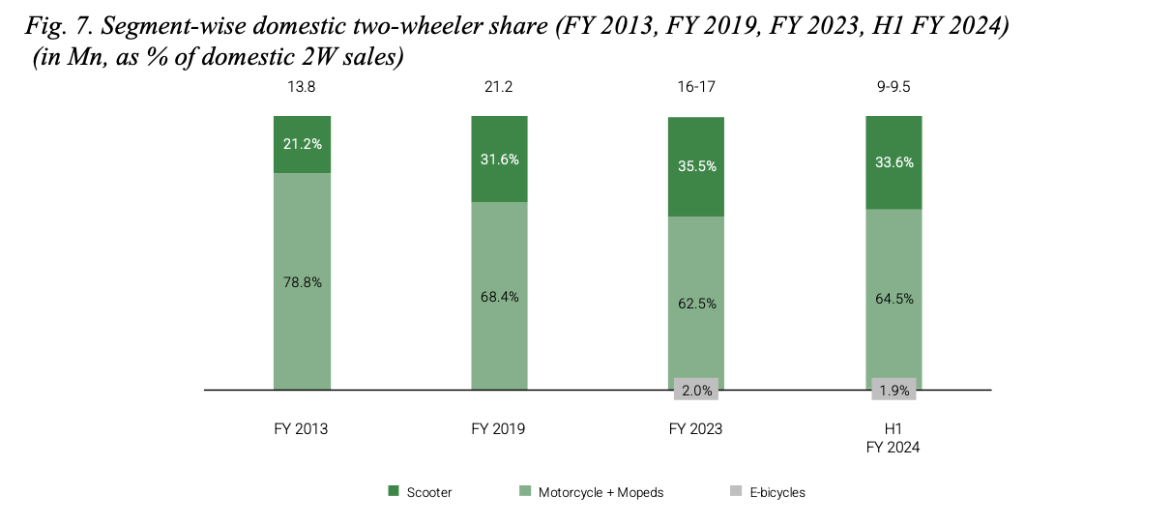

Target Demographics :

Ola Electric’s core customer base primarily consists of urban and semi-urban commuters aged 20 to 45, who are digitally savvy, cost-conscious, and increasingly environmentally aware. These users prioritize low operational costs, convenience, and sustainability.
The customer base is increasing with our expansion into Motorcycles using Roadster as well as E-bikes such as Ola Gig .
India is seeing a EV boom not only in urban cities but also in Tier-2 and Tier-3 cities where Ola is the sole Market leader with over 50% market share. The vast retail store network combined with strong online store Prescence has allowed ola to dominate this market.

The healthy demand from Indian cities is observed in the graph below which shows high demand from Tier-1 and Tier-2 cities ,
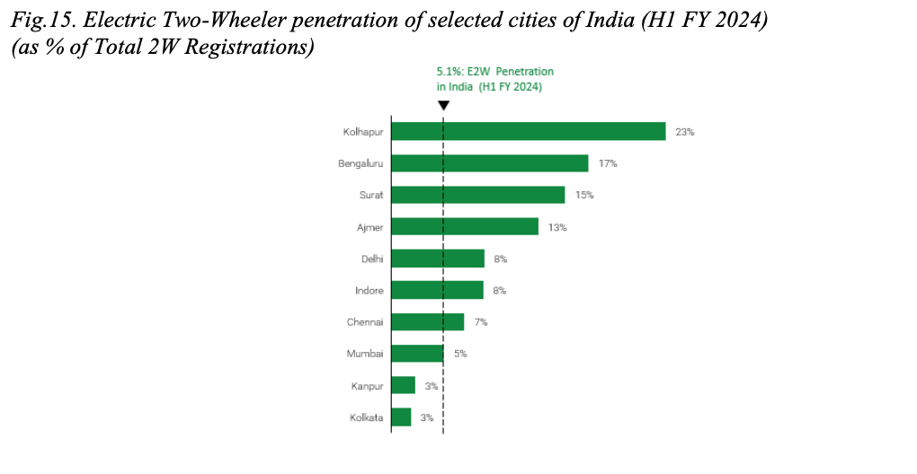

Future growth:

The strong adoption is only the beginning as EV 2W’s are at the inflection point where all revolutionary technologies were before mass-adoption , The category sales penetration curves of E2Ws , Smartphones and Laptops show high adoption of Electric vehicles even in early stages showing that the next decade is crucial and the most lucrative.
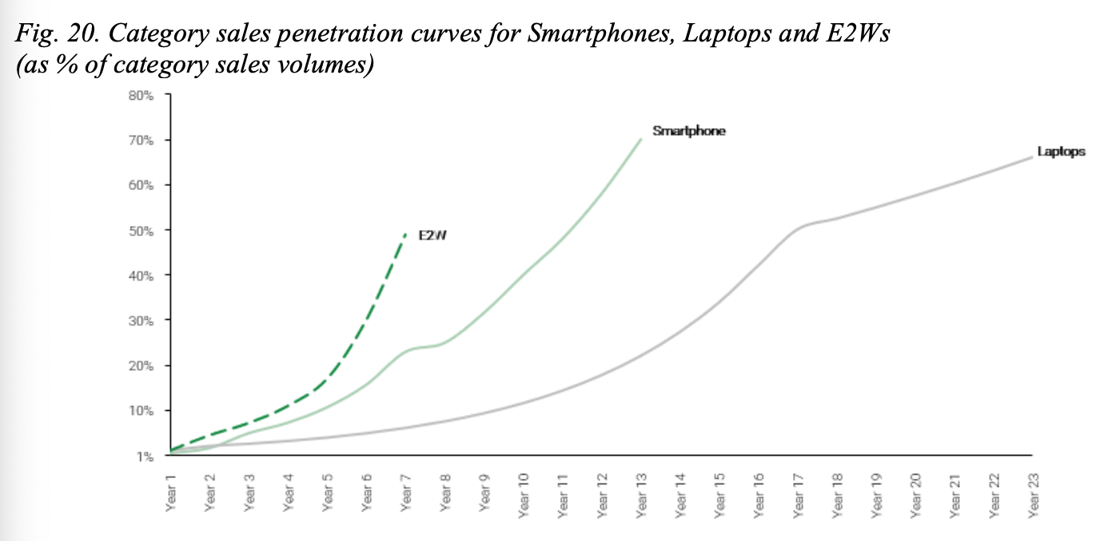

INDUSTRY GROWTH CATALYST:

1)Government Policy & Rising EV adoption:
Government push (FAME-II subsidies, PLI schemes) and rising fuel prices have accelerated the shift to electric mobility. With 2W EVs forming over 60% of India’s EV sales, Ola is ideally positioned to capitalize on the transition from ICE to EV vehicles.

This can be seen in the graph below depicting no_of_units sold per year:

With post pandemic rise being strong at 11% CAGR ,the market is predicted to reach $35-45Billion valuation by FY2028.Growing middle class population and increasing urbanization are key contributors.

2)Expansion of Hypercharging Network
The charging infrastructure for EV’s is a crucial piece of the puzzle , electric charging stations have almost been doubling every year with all major players investing heavily,

Ola electric has one of the most robust charging network in the country allowing for a wide reach
The company operates approximately 1000 fast charging point(end of 2024) with plans set in place for 10,000 stations by the end of FY2026

3)Technology Differentiation via software

Software has been a clear differentiator between ICE and EV’s , with EV’s offering features like OTA updates, predictive maintenance, voice commands, and app-based control enhance user experience and create recurring software monetization potential.

Ola through moveOS has sold the idea of software integration to enhance driving experience.
The industry is playing catchup with Ola electrics software and keyless entry into vehicles.

Global Expansion:

The Indian E2W market is still in its infancy but growing at an extraordinary pace. Increased government spending and industry-wide innovation will make the rise of electric vehicles inevitable in India. Furthermore, international demand is also increasing — especially from South Africa and South America.

Ola is already tapping into this opportunity, with 18% of its total scooters exported in 2023,primarily to African countries and talks for broader international expansion currently underway.

Financial Performance & Projections
Ola Electric – Financial Performance

Ola Electric Mobility Ltd. has demonstrated remarkable revenue growth since FY2021, expanding from a nascent stage into one of India’s largest EV manufacturers. The company’s revenue from operations surged from ₹0.86 Cr in FY2021 to ₹5,514 Cr in FY2025, a CAGR of ~500%+ over four years. While the company continues to incur operating losses, the margin of loss as a percentage of revenue has been narrowing, and strategic investments in infrastructure, R&D, and workforce have set the stage for future breakeven.

The Journey of the company can be broadly segregated into two phases:

Phase 1: Hyper-Growth & Market Capture (FY22-FY25) The financial statements from this period reflect the Company's strategic priority: rapid market penetration and infrastructure development.
- Revenue Growth: Revenue from operations surged from ₹373.44 Cr in FY22 to ₹5,514 Cr in FY25, a CAGR of over 500% over four years.
- Operating Losses: These were driven by three key strategic investments:
  - Infrastructure Capex: Building the FutureFactory and Gigafactory.
  - Heavy R&D Spend: Developing the proprietary 4680 cell, HRE-free motors, and the MoveOS platform.
  - Market Acquisition Costs: This includes aggressive pricing, marketing, and the rapid expansion of the retail , service network to over 4,000 stores. Including the parallel buildout of a nationwide charging infrastructure as a core strategic pillar.

Stock price of Ola electric (2023-2025)
The chart below presents the historical share price performance from August 2024 through July 2025. During this period, the Company's valuation experienced a significant decline from a high of ₹117.93 before stabilizing in the ₹40-₹50 range in mid-2025.

Strategic Context for Historical Share Price Performance
The chart below presents the historical share price performance from August 2024 through July 2025. During this period, the Company's valuation experienced a significant decline from a high of ₹117.93 before stabilizing in the ₹40-₹50 range in mid-2025.

This performance is a direct reflection of a period of the most intensive capital investment in the Company's history. The valuation decline coincided with planned, peak expenditures on building the FutureFactory and the Gigafactory , significant R&D spending on proprietary 4680 battery cell technology , and aggressive market acquisition strategies designed to secure long-term market dominance. This strategic focus on building a deep competitive moat prioritized market share and vertical integration over short-term profitability, resulting in operating losses that were reflected in public market sentiment during that period.

Management views this foundational investment phase as successfully completed. With the core infrastructure now in place, the strategic focus has shifted decisively toward operational efficiency and translating market leadership into financial performance. Initiatives such as 'Project Lakshya' are specifically designed to improve gross margins from 19% to 36.5% and drive the Company toward profitability by FY2027. Therefore, we believe the current valuation represents a strategic entry point that does not yet fully account for the future earnings potential unlocked by these foundational investments.

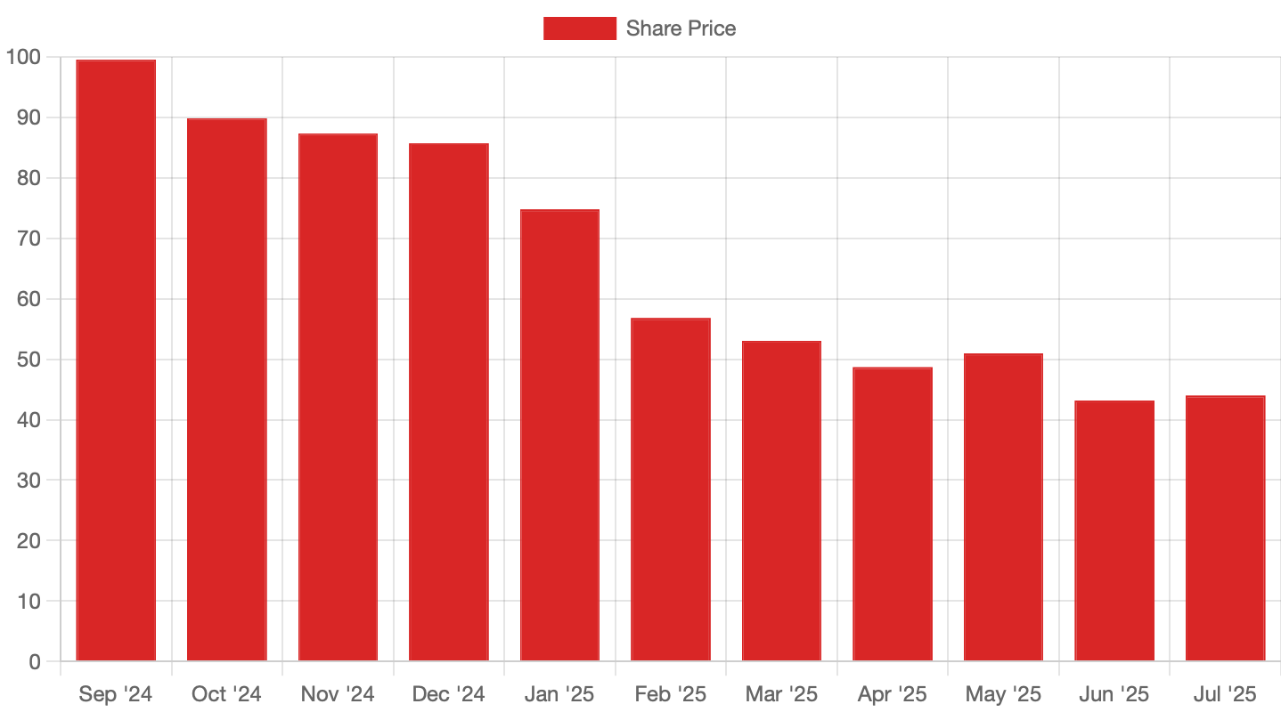

1. Revenue and Loss Trends(All in INR CR)
Particulars (₹ Cr) | FY2021 | FY2022 | FY2023 | FY2024 | FY2025
Revenue from Operations | 0.86 | 373.44 | 2,605.97 | 5,010.00 | 5,514.00
Total Income | 1.07 | 1,068.81 | 2,742.71 | 5,243.00 | 4,932.00
Total Expenses | 2,840.93 | 11,872.78 | 16,311.25 | 6,278.00 | 6,283.00
EBITDA | -1,750 | -7,844 | -14,729 | -1,392 | -1,721
EBIT | -1,992 | -7,541 | -13,576 | -1,580 | -2,253
Net Loss | -1,992 | -7,541 | -14,729 | -1,586 | -2,276
Net Loss % of Revenue | (2,317%) | (2,019%) | (565%) | (31.7%) | (41.3%)
While absolute losses widened in FY2025, the loss as a % of revenue has dropped drastically compared to earlier years (e.g., 2,317% in FY2021 vs. 41.3% in FY2025), reflecting operating leverage and improved cost absorption. Ola electric is committed towards achieving profit by FY-2027.

2. Key Balance Sheet Highlights (as of FY-End) )(All in INR CR)
Balance Sheet Item (₹ Cr) | FY2021 | FY2022 | FY2023 | FY2024 | Q1 FY2026
Total Assets | 3,112 | 8,598 | 13,599 | 21,116 | 27,114
Equity Share Capital | 0.10 | 0.10 | 0.10 | 19,554 | 19,554
Reserves & Surplus | (192.98) | (688.04) | (1,354.60) | (2,909) | (10,233)
Total Equity | (192.85) | (687.94) | (1,354.50) | 16,645 | 9,321
Total Liabilities | 3,304 | 9,286 | 14,953 | 4,471 | 17,793
Cash & Cash Equivalents | 289.34 | 1,007.17 | 1,342.08 | 2,462 | 3,661
Borrowings (Total) | 388.72 | 2,266.17 | 9,945 | 7,009 | 16,063

Summary Table of Key Financial Metrics (FY2021–FY2025)(All in INR CR)
Metric | FY2021 | FY2022 | FY2023 | FY2024 | FY2025
Revenue (₹ Cr) | 0.86 | 373.44 | 2,605.97 | 5,010 | 5,514
EBITDA (₹ Cr) | -1,750 | -7,844 | -14,729 | -1,392 | -1,721
EBIT (₹ Cr) | -1,992 | -7,541 | -13,576 | -1,580 | -2,253
Net Loss (₹ Cr) | -1,992 | -7,541 | -14,729 | -1,586 | -2,276
EPS (₹) | (0.99) | (2.23) | (3.91) | (4.35) | (5.48)
Total Assets (₹ Cr) | 3,112 | 8,598 | 13,599 | 21,116 | 27,114
Equity (₹ Cr) | (192.85) | (687.94) | (1,354.50) | 16,645 | 9,321
Borrowings (₹ Cr) | 388.72 | 2,266.17 | 9,945 | 7,009 | 16,063
Cash & Equivalents (₹ Cr) | 289.34 | 1,007.17 | 1,342.08 | 2,462 | 3,661

Phase 2: The Turn to Profitability (FY26 Onward) Management has instituted a clear plan to translate market leadership into financial strength, with a commitment to achieving a +ve EBITA by FY2027.
Pathway to 36.5% Gross Margin: "Project Lakshya" The projection of improving gross margins from 19% to 36.5% by Q2 FY2026 is the cornerstone of the investment thesis.
The projected margin expansion Is underpinned by 3 drivers:
- Vertical Integration Savings: As the Gigafactory scales, reliance on third-party battery components will decrease, significantly reducing the cost of materials, which currently accounts for ~65% of total expenses.
- Next-Generation Technology: The launch of the indigenously developed Heavy Rare Earth (HRE) free motors in FY2026 is projected to materially reduce costs and insulate the Company from geopolitical supply chain risks.
- Headroom for increasing Gross Margins wrt to industry: The given comparison shoes the difference in gross margins from sale of scooters
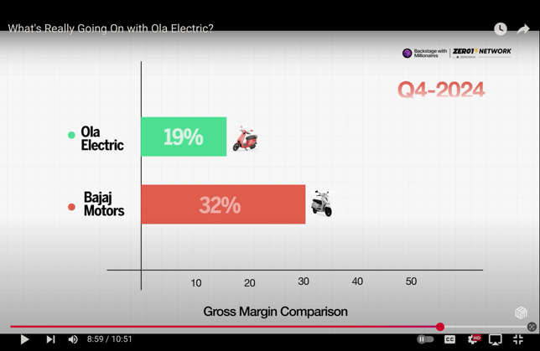
Our aim is to close the gap to legacy automakers in the market with this project and reach 30% gross margin by Q1 FY2026 AND 36.5% by Q2 FY2026
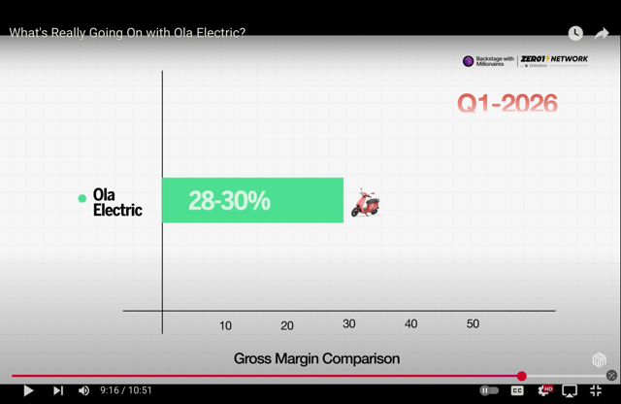
Achieving the goals will facilitate a +ve EBITA by Q3 FY2026 at the latest.

Project Vistaar:
Ola electric has listened to customer concerns about long waiting times and issues with service centers , With our 1000+ Service centers we have been able to cut service times from 12 days to 3-4days on average. Our goal through this project remains to streamline inventory and enable same-day delivery via HyperDelivery

Risk Factors
A prospective investor should consider the following risks:
- Financial Risk & Capital Dependency: The Company remains loss-making and will require significant capital to fund operations until it achieves positive free cash flow. The success of the investment is contingent on achieving the projected turnaround.
- Execution Risk: The ambitious targets for margin improvement and new product launches are subject to significant execution risk.
- Intense Competition: The E2W market is highly competitive, with well-capitalized legacy players (TVS, Bajaj) and other EV-native companies (Ather) competing aggressively.
- Regulatory Uncertainty: The business has benefited significantly from government subsidies (FAME-II). Any adverse changes to these policies could impact demand and profitability.
- Key-Person Risk: The Company's strategy and vision are closely tied to its founder, Bhavish Aggarwal. A successful transition will require institutionalizing this vision within a durable management structure.

https://www.businesstoday.in/magazine/the-buzz/story/indias-electric-two-wheeler-market-is-no-longer-a-niche-segment-but-a-battleground-for-both-start-ups-and-legacy-players-464880-2025-02-18

